Irregular Tessellation
# Source: AI Source: Provided by: [Data Path: Persons Table -> ID Column: 1, Name_En Column: Motasem Essam] -> From: [ChatGPT] on [7/25/2026]
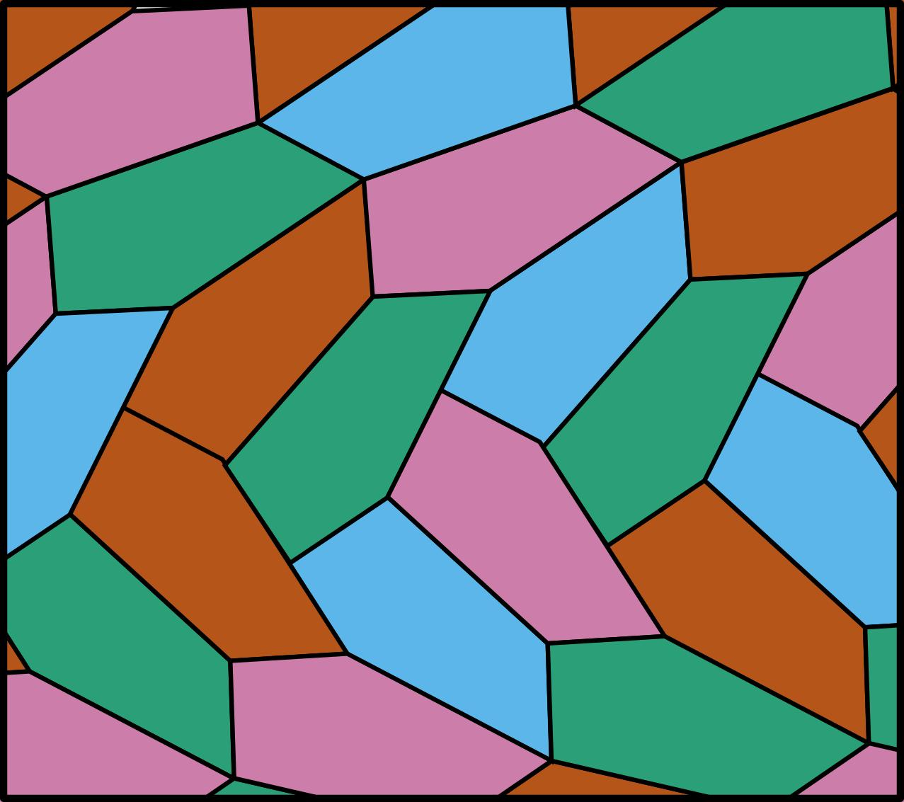
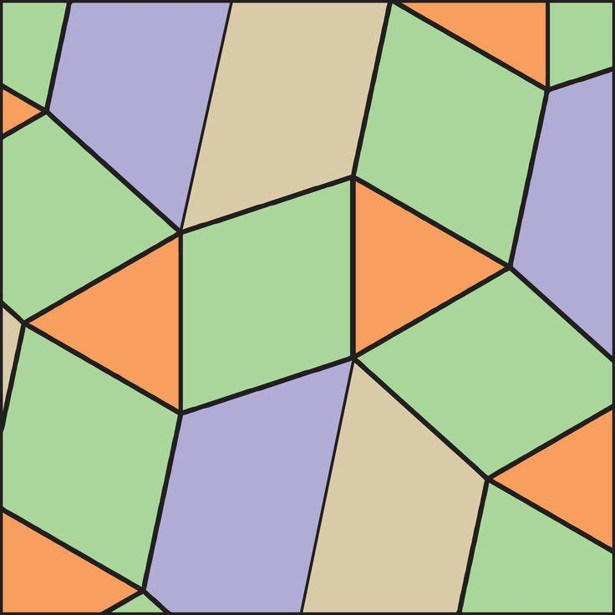
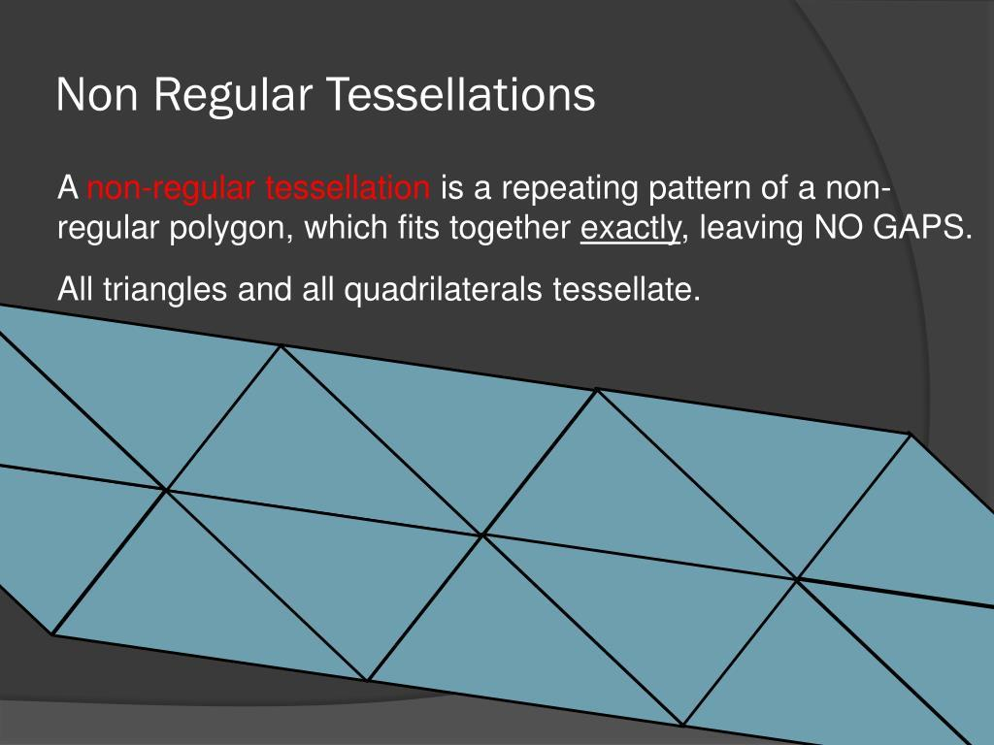
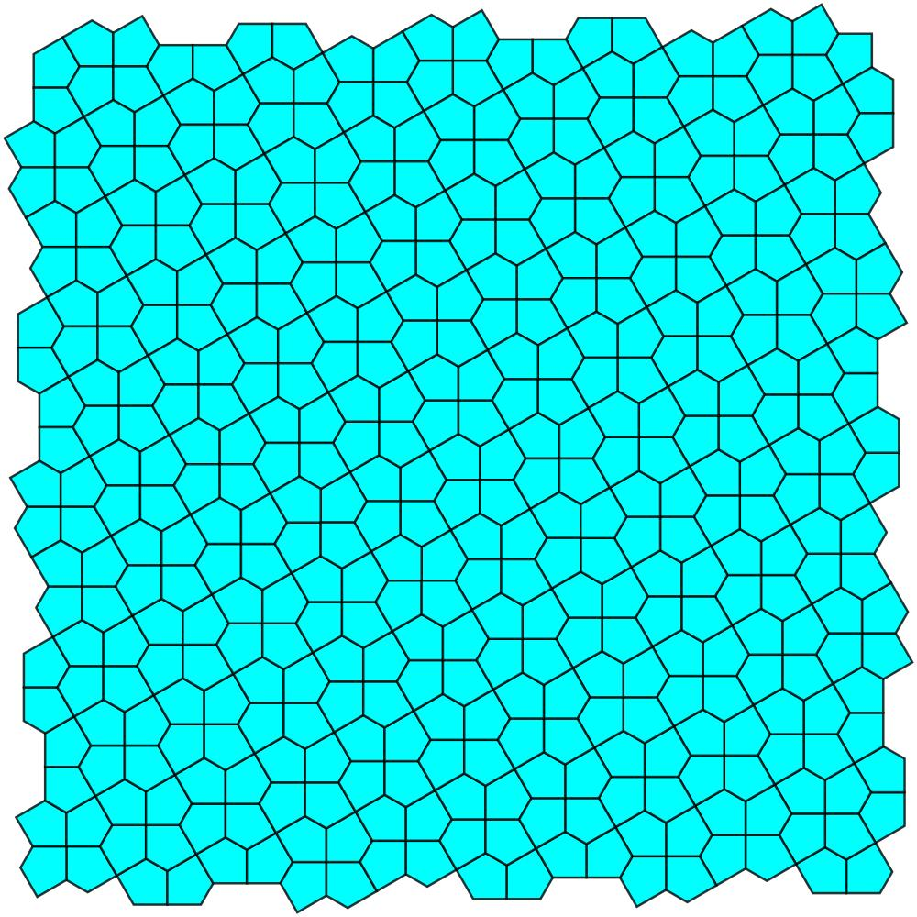
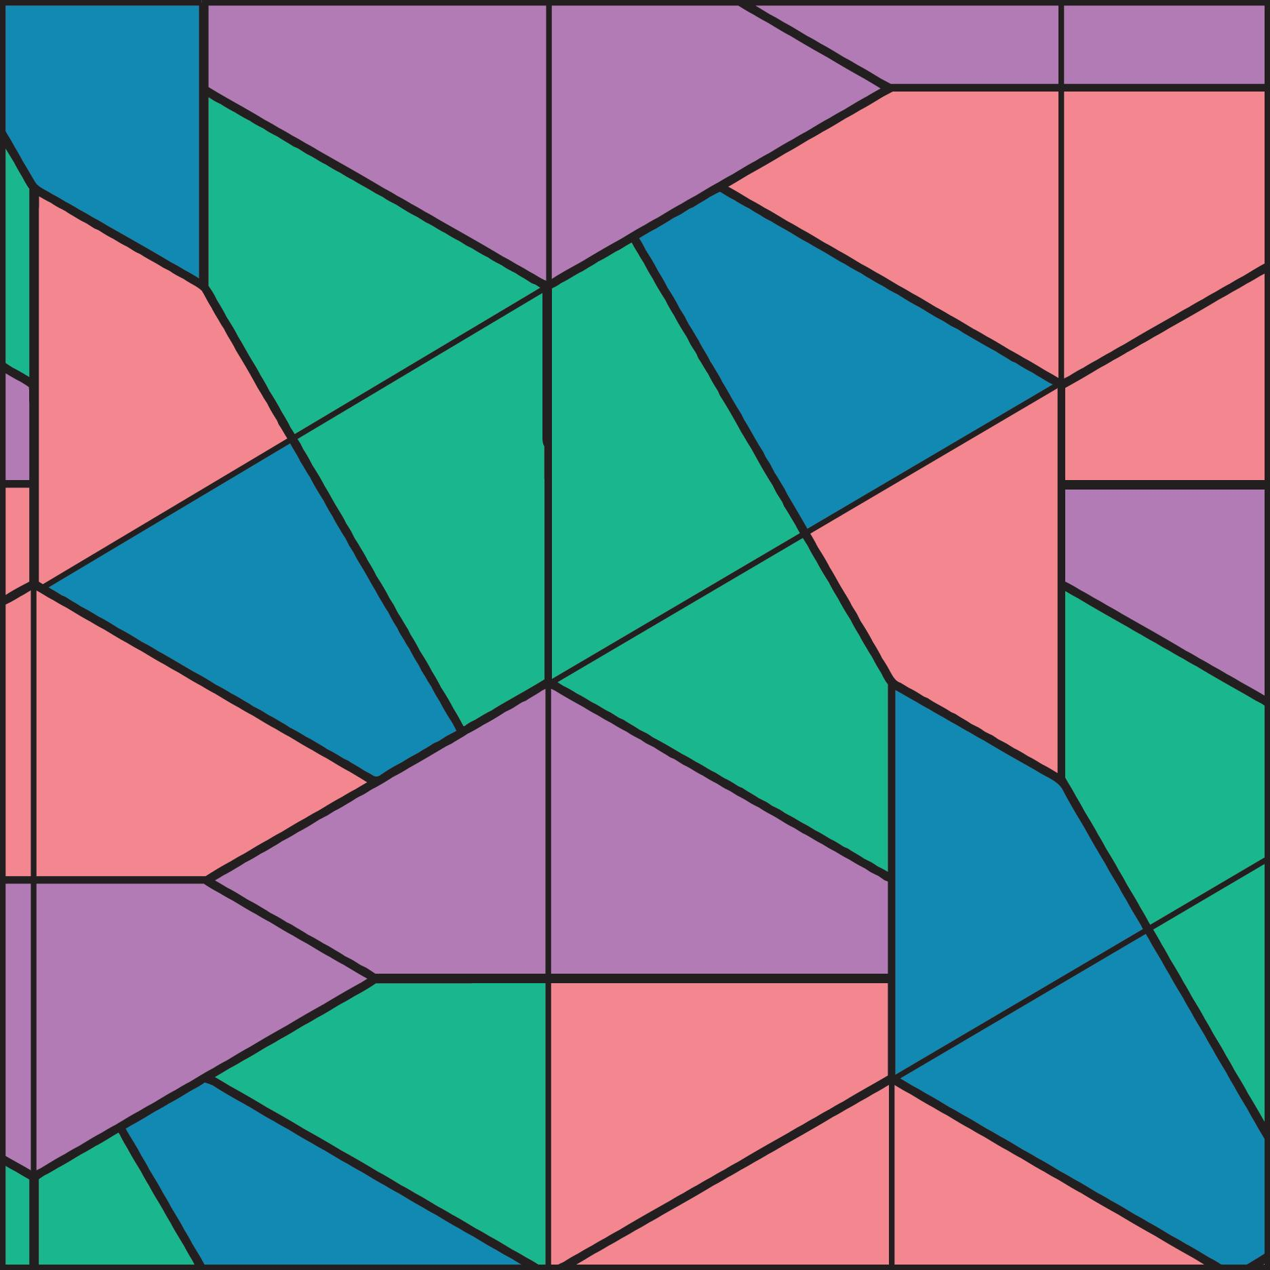

Definition
# Source: AI Source: Provided by: [Data Path: Persons Table -> ID Column: 1, Name_En Column: Motasem Essam] -> From: [ChatGPT] on [7/25/2026]
An Irregular Tessellation is a tessellation of a plane that uses polygons or other shapes that are not restricted to a single regular polygon with a uniform regular vertex arrangement.
The tiles completely cover the plane:
$$\boxed{\text{No Gaps and No Overlaps}}$$
Unlike a Regular Tessellation, an irregular tessellation does not require all tiles to be the same type of regular polygon.
Unlike a Semi-Regular Tessellation, it does not require the same combination of regular polygons to occur around every vertex.

Purpose
# Source: AI Source: Provided by: [Data Path: Persons Table -> ID Column: 1, Name_En Column: Motasem Essam] -> From: [ChatGPT] on [7/25/2026]
Irregular tessellations are used to:
- Study how non-regular shapes can cover a plane.
- Investigate polygon angles and side relationships.
- Create non-uniform geometric patterns.
- Model natural and artificial surfaces.
- Explore geometric transformations and symmetry.

Fundamental Elements

1. Tile
# Source: AI Source: Provided by: [Data Path: Persons Table -> ID Column: 1, Name_En Column: Motasem Essam] -> From: [ChatGPT] on [7/25/2026]
The tile is the individual shape used to construct the tessellation.
Tiles may be:
- Irregular triangles
- Irregular quadrilaterals
- Irregular pentagons
- Other polygons
- Different polygon types combined together

2. Vertex
# Source: AI Source: Provided by: [Data Path: Persons Table -> ID Column: 1, Name_En Column: Motasem Essam] -> From: [ChatGPT] on [7/25/2026]
A vertex is a point where two or more tiles meet.
3. Edge
An edge is the boundary of a tile.
4. Vertex Arrangement
The shapes and angles surrounding a vertex determine whether the tiles can fit together.
For an ordinary interior vertex:
$$\boxed{θ_{1}+θ_{2}+⋯+θ_{n}={360}^{∘}}$$

Main Characteristics
# Source: AI Source: Provided by: [Data Path: Persons Table -> ID Column: 1, Name_En Column: Motasem Essam] -> From: [ChatGPT] on [7/25/2026]
An irregular tessellation generally has:
- Non-regular tiles, or a non-uniform mixture of tiles.
- No requirement that all tiles be congruent.
- No requirement for a uniform vertex configuration.
- Complete coverage of the plane.
- No gaps.
- No overlaps.
However, irregular does not mean random. An irregular tessellation still has to satisfy the geometric conditions necessary to cover the plane.

Types of Irregular Tessellations
# Source: AI Source: Provided by: [Data Path: Persons Table -> ID Column: 1, Name_En Column: Motasem Essam] -> From: [ChatGPT] on [7/25/2026]
A useful classification is:
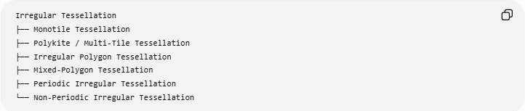
Irregular Tessellation
├── Monotile Tessellation
├── Polykite / Multi-Tile Tessellation
├── Irregular Polygon Tessellation
├── Mixed-Polygon Tessellation
├── Periodic Irregular Tessellation
└── Non-Periodic Irregular Tessellation
These categories can overlap because they classify different aspects of the tessellation.

1. Monotile Tessellation
# Source: AI Source: Provided by: [Data Path: Persons Table -> ID Column: 1, Name_En Column: Motasem Essam] -> From: [ChatGPT] on [7/25/2026]
A Monotile Tessellation uses copies of a single tile shape.
The tile does not have to be a regular polygon.
For example, an irregular quadrilateral can sometimes tessellate the plane through translations, rotations, or reflections.
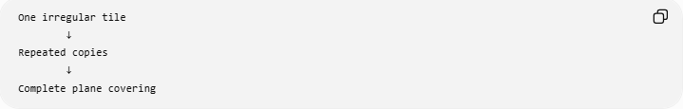
One irregular tile
↓
Repeated copies
↓
Complete plane covering
If the tile is irregular, the resulting tessellation can still be classified as an irregular tessellation.

2. Multi-Tile Tessellation
# Source: AI Source: Provided by: [Data Path: Persons Table -> ID Column: 1, Name_En Column: Motasem Essam] -> From: [ChatGPT] on [7/25/2026]
A Multi-Tile Tessellation uses more than one tile shape.
For example:
- Irregular triangles + irregular quadrilaterals
- Different types of quadrilaterals
- Several different polygon shapes
The arrangement does not need to have the uniformity required by a semi-regular tessellation.

3. Irregular Polygon Tessellation
# Source: AI Source: Provided by: [Data Path: Persons Table -> ID Column: 1, Name_En Column: Motasem Essam] -> From: [ChatGPT] on [7/25/2026]
An Irregular Polygon Tessellation uses polygons that are not regular.
Examples include:
- Irregular triangles
- Irregular quadrilaterals
- Irregular pentagons
- Irregular hexagons
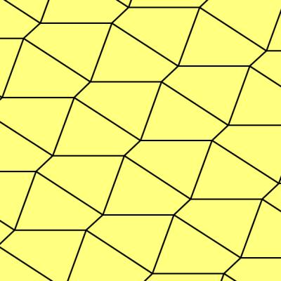
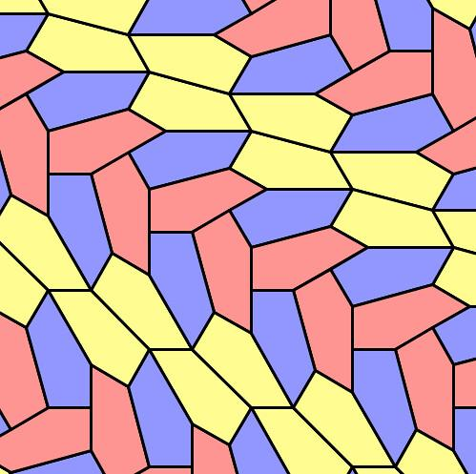
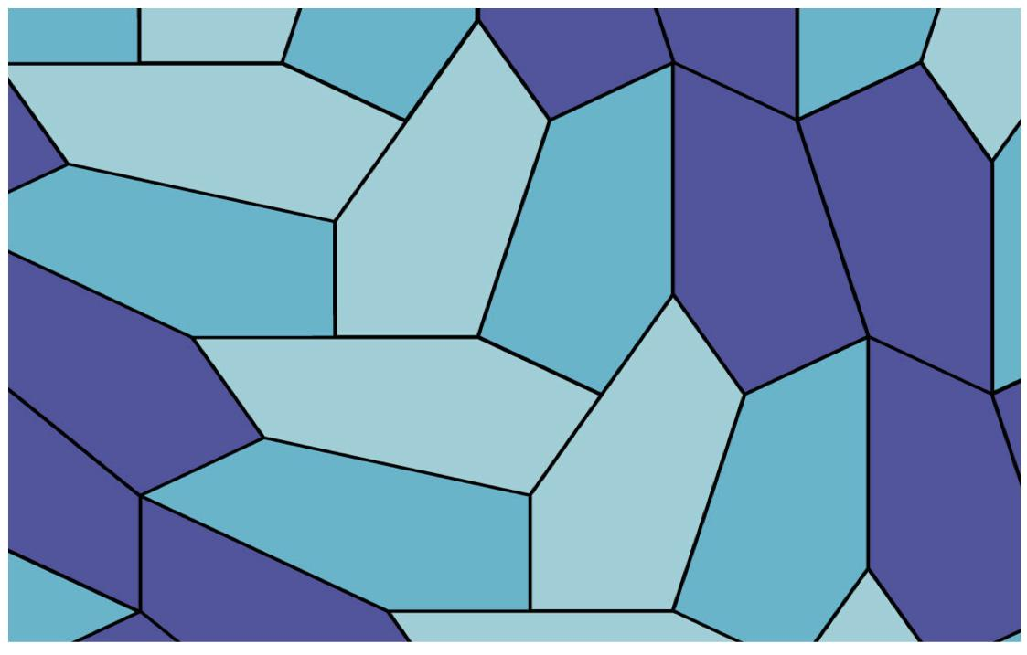
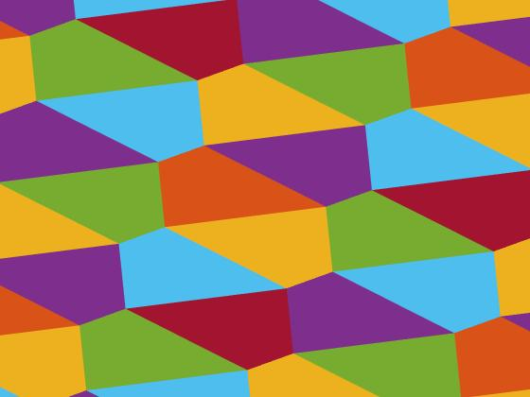
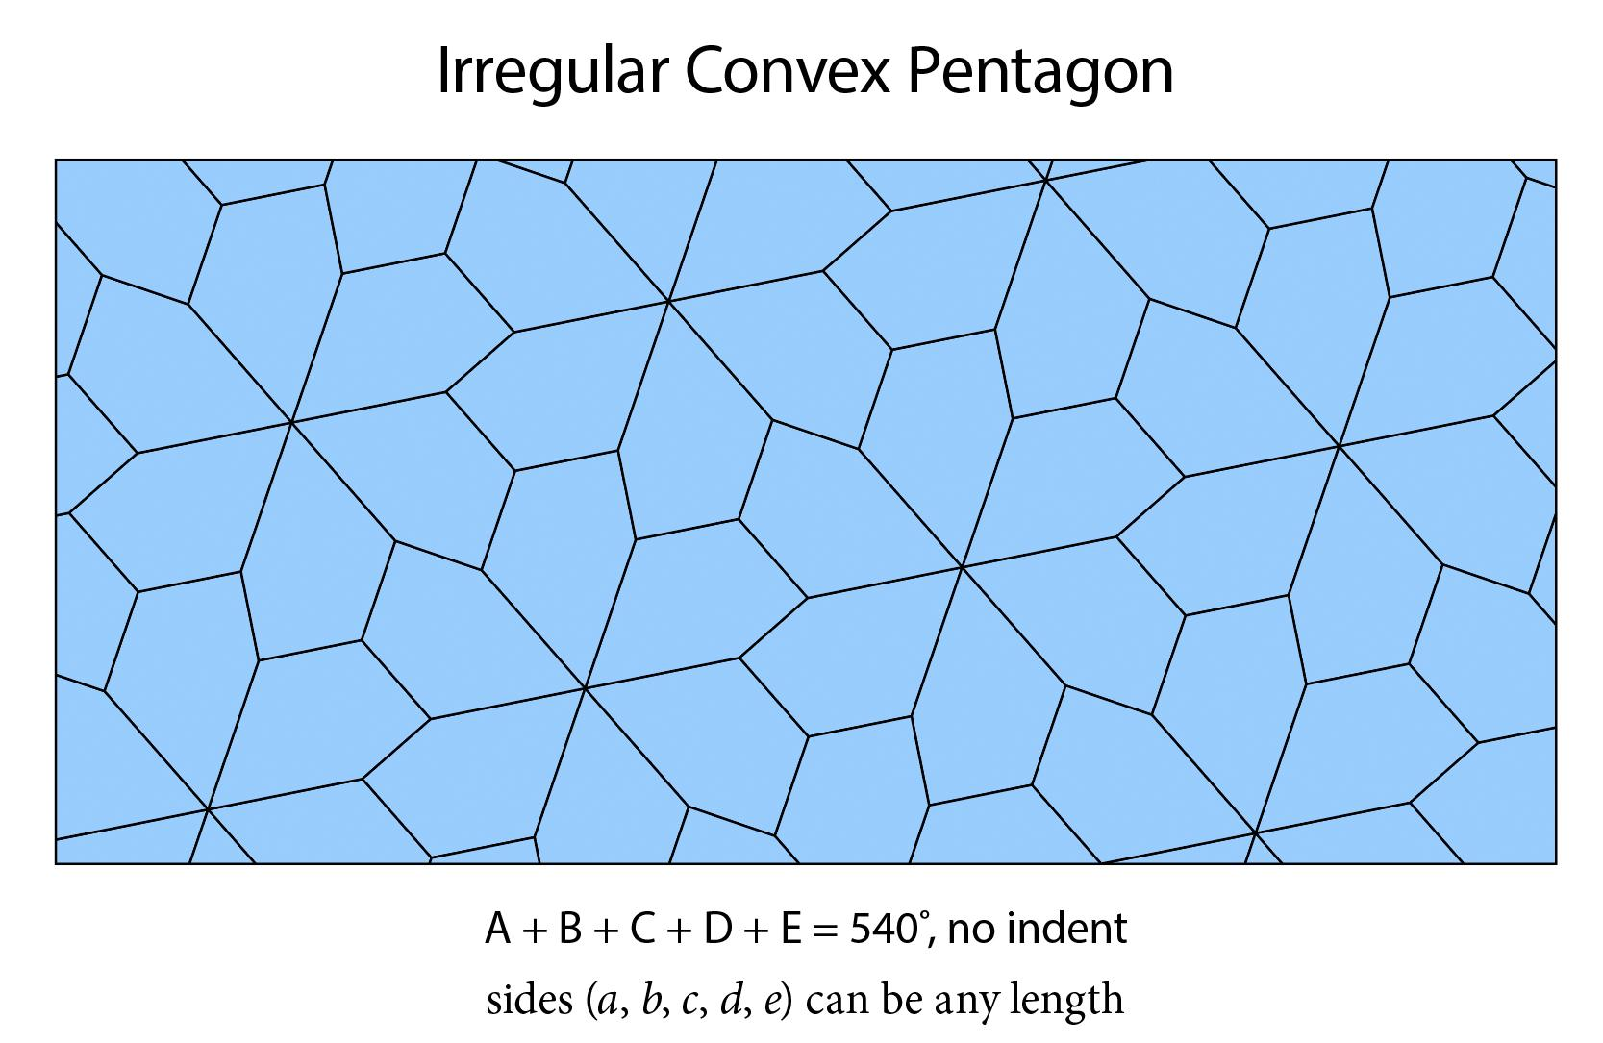

4. Mixed-Polygon Tessellation
# Source: AI Source: Provided by: [Data Path: Persons Table -> ID Column: 1, Name_En Column: Motasem Essam] -> From: [ChatGPT] on [7/25/2026]
A Mixed-Polygon Tessellation uses different polygon types.
For example:
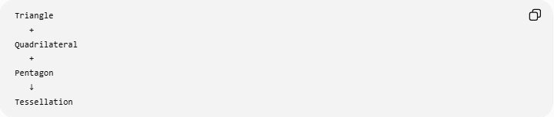
Triangle
+
Quadrilateral
+
Pentagon
↓
Tessellation
The polygons must still fit together so that the plane is completely covered.

Periodic Irregular Tessellation
# Source: AI Source: Provided by: [Data Path: Persons Table -> ID Column: 1, Name_En Column: Motasem Essam] -> From: [ChatGPT] on [7/25/2026]
An irregular tessellation can still be periodic.
This means that although the tiles are irregular, a repeating unit exists.
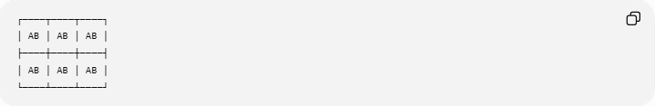
┌────┬────┬────┐
│ AB │ AB │ AB │
├────┼────┼────┤
│ AB │ AB │ AB │
└────┴────┴────┘
Therefore:
$$\boxed{\text{Irregular}⇏\text{Non-Periodic}}$$
"Irregular" describes the tiles or arrangement, while "periodic" describes whether the overall pattern repeats.

Non-Periodic Irregular Tessellation
# Source: AI Source: Provided by: [Data Path: Persons Table -> ID Column: 1, Name_En Column: Motasem Essam] -> From: [ChatGPT] on [7/25/2026]
An irregular tessellation can also be non-periodic.
Such a tessellation does not have a simple translational repeating unit.
This gives another independent classification:
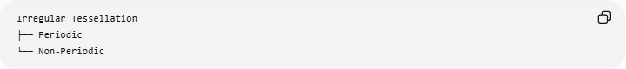
Irregular Tessellation
├── Periodic
└── Non-Periodic

Angle Condition
# Source: AI Source: Provided by: [Data Path: Persons Table -> ID Column: 1, Name_En Column: Motasem Essam] -> From: [ChatGPT] on [7/25/2026]
The most important local geometric requirement is that the angles surrounding an interior point add to:
$$\boxed{{360}^{∘}}$$
For example, suppose four irregular tiles meet at a vertex with angles:
$${80}^{∘}, {100}^{∘}, {70}^{∘}, {110}^{∘}$$
Then:
$${80}^{∘}+{100}^{∘}+{70}^{∘}+{110}^{∘}={360}^{∘}$$
So the angles fit exactly around the vertex.

Irregular Tessellation vs Regular Tessellation
# Source: AI Source: Provided by: [Data Path: Persons Table -> ID Column: 1, Name_En Column: Motasem Essam] -> From: [ChatGPT] on [7/25/2026]
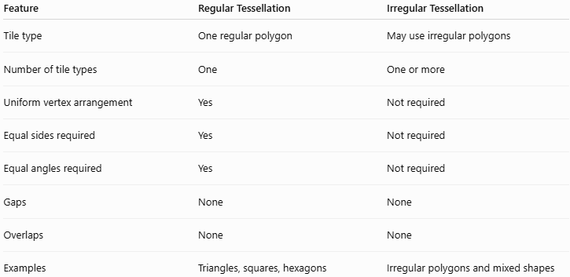
Feature | Regular Tessellation | Irregular Tessellation
Tile type | One regular polygon | May use irregular polygons
Number of tile types | One | One or more
Uniform vertex arrangement | Yes | Not required
Equal sides required | Yes | Not required
Equal angles required | Yes | Not required
Gaps | None | None
Overlaps | None | None
Examples | Triangles, squares, hexagons | Irregular polygons and mixed shapes

Irregular Tessellation vs Semi-Regular Tessellation
# Source: AI Source: Provided by: [Data Path: Persons Table -> ID Column: 1, Name_En Column: Motasem Essam] -> From: [ChatGPT] on [7/25/2026]
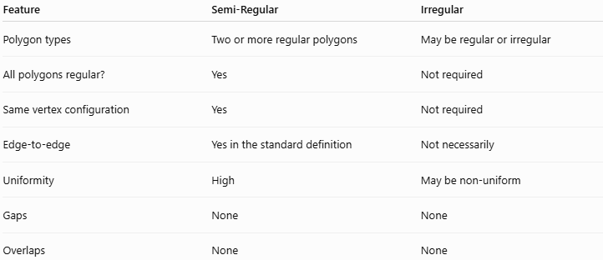
Feature | Semi-Regular | Irregular
Polygon types | Two or more regular polygons | May be regular or irregular
All polygons regular? | Yes | Not required
Same vertex configuration | Yes | Not required
Edge-to-edge | Yes in the standard definition | Not necessarily
Uniformity | High | May be non-uniform
Gaps | None | None
Overlaps | None | None
The important distinction is uniformity.
A semi-regular tessellation has a highly controlled, repeating vertex arrangement, whereas an irregular tessellation does not have that requirement.

Examples

Example 1 — Irregular Quadrilateral
# Source: AI Source: Provided by: [Data Path: Persons Table -> ID Column: 1, Name_En Column: Motasem Essam] -> From: [ChatGPT] on [7/25/2026]
An irregular quadrilateral can tessellate the plane when copies are arranged appropriately.
It does not need to have:
$$\text{all sides equal}$$
or
$$\text{all angles equal}$$
Yet the copies can still cover the plane without gaps or overlaps.

Example 2 — Mixed Shapes
# Source: AI Source: Provided by: [Data Path: Persons Table -> ID Column: 1, Name_En Column: Motasem Essam] -> From: [ChatGPT] on [7/25/2026]
A pattern can combine different irregular polygons:
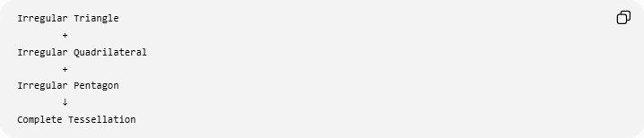
Irregular Triangle
+
Irregular Quadrilateral
+
Irregular Pentagon
↓
Complete Tessellation
The specific angles at every meeting point must still fit together.

Symmetry
# Source: AI Source: Provided by: [Data Path: Persons Table -> ID Column: 1, Name_En Column: Motasem Essam] -> From: [ChatGPT] on [7/25/2026]
Irregular tessellations may have:
- Translation symmetry
- Reflection symmetry
- Rotational symmetry
- Glide-reflection symmetry
- Little or no obvious symmetry
Therefore:
$$\boxed{\text{Irregular does not mean asymmetrical}}$$
An irregular tessellation can still possess significant symmetry.

Relationship to Other Tessellations
# Source: AI Source: Provided by: [Data Path: Persons Table -> ID Column: 1, Name_En Column: Motasem Essam] -> From: [ChatGPT] on [7/25/2026]
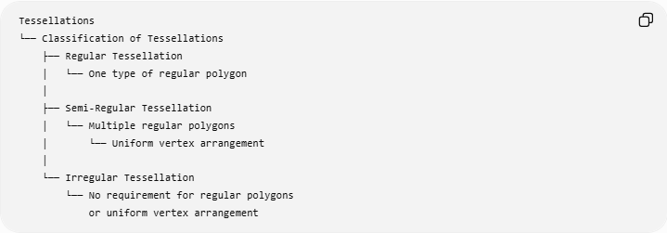
Tessellations
└── Classification of Tessellations
├── Regular Tessellation
│ └── One type of regular polygon
│
├── Semi-Regular Tessellation
│ └── Multiple regular polygons
│ └── Uniform vertex arrangement
│
└── Irregular Tessellation
└── No requirement for regular polygons
or uniform vertex arrangement
A second classification can be made independently according to repetition:
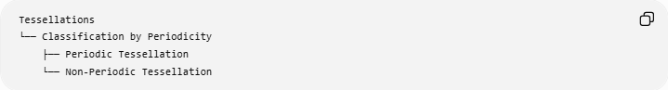
Tessellations
└── Classification by Periodicity
├── Periodic Tessellation
└── Non-Periodic Tessellation
This distinction is important because a tessellation can be irregular and periodic or irregular and non-periodic.

Real-World Applications
# Source: AI Source: Provided by: [Data Path: Persons Table -> ID Column: 1, Name_En Column: Motasem Essam] -> From: [ChatGPT] on [7/25/2026]
Irregular tessellations appear in:
- Natural stone arrangements
- Ceramic and decorative tile patterns
- Pavement designs
- Architectural surfaces
- Textile patterns
- Computer graphics
- Irregular mesh generation
- Artistic geometric patterns
- Modeling surfaces and spatial regions
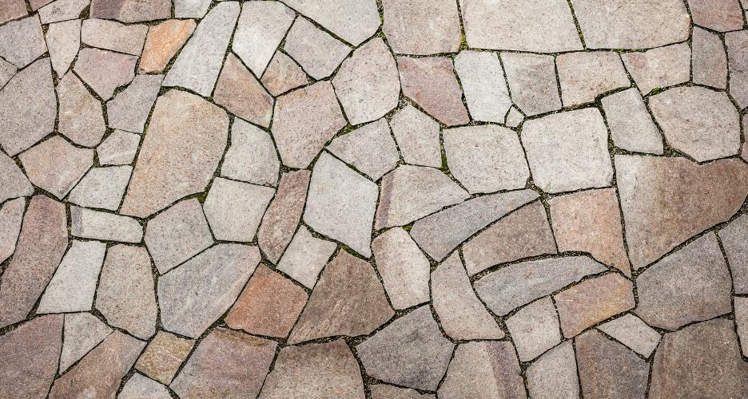
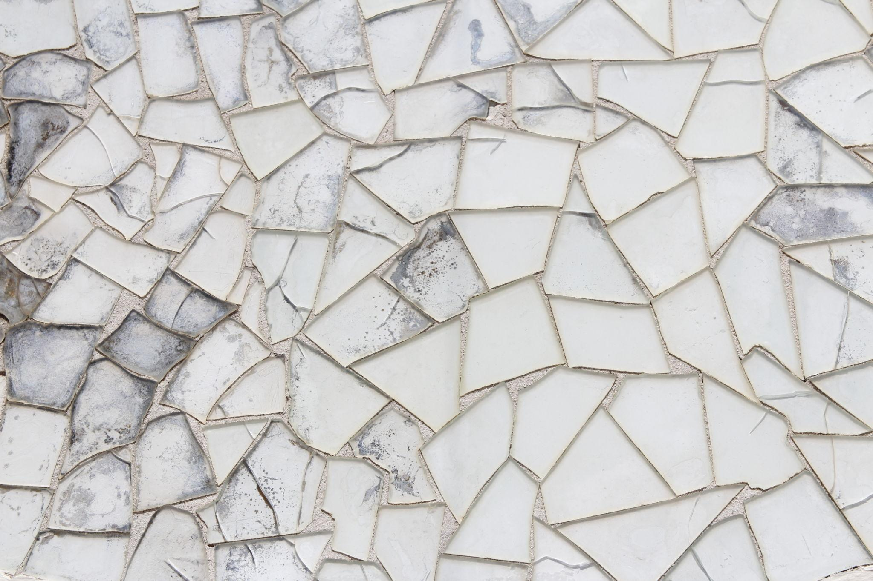
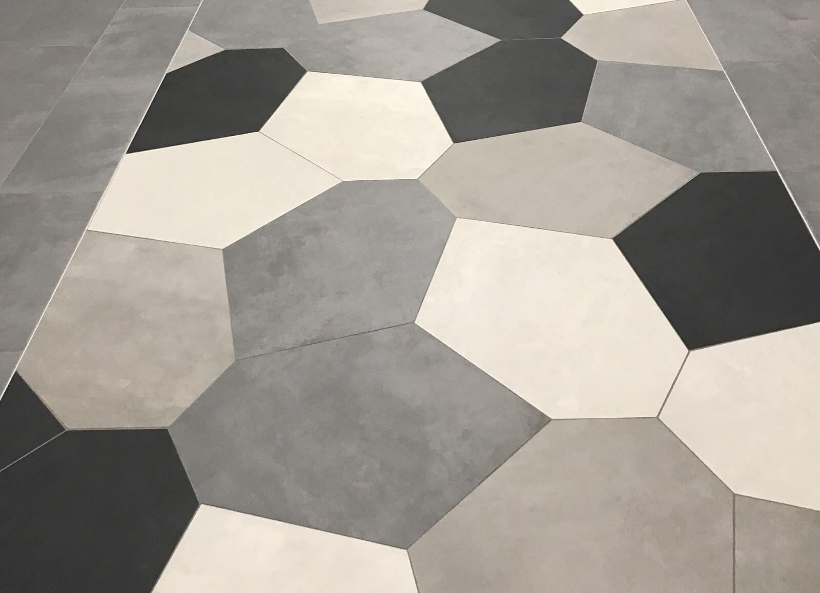
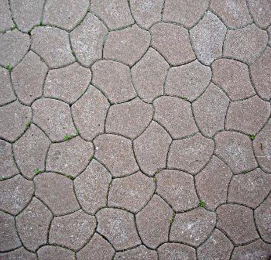
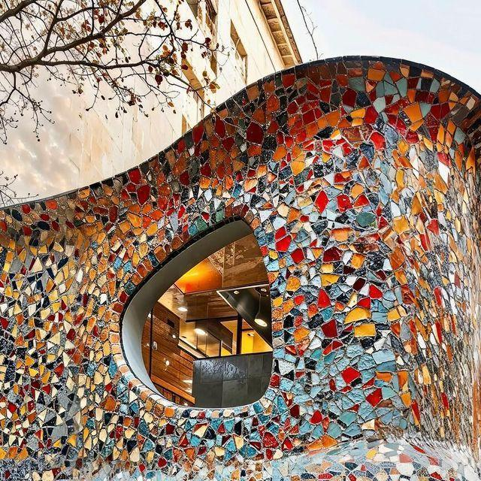
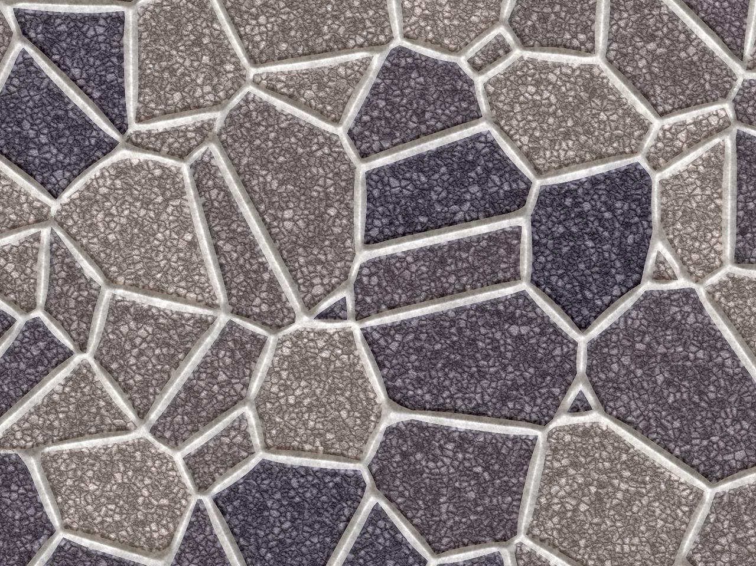
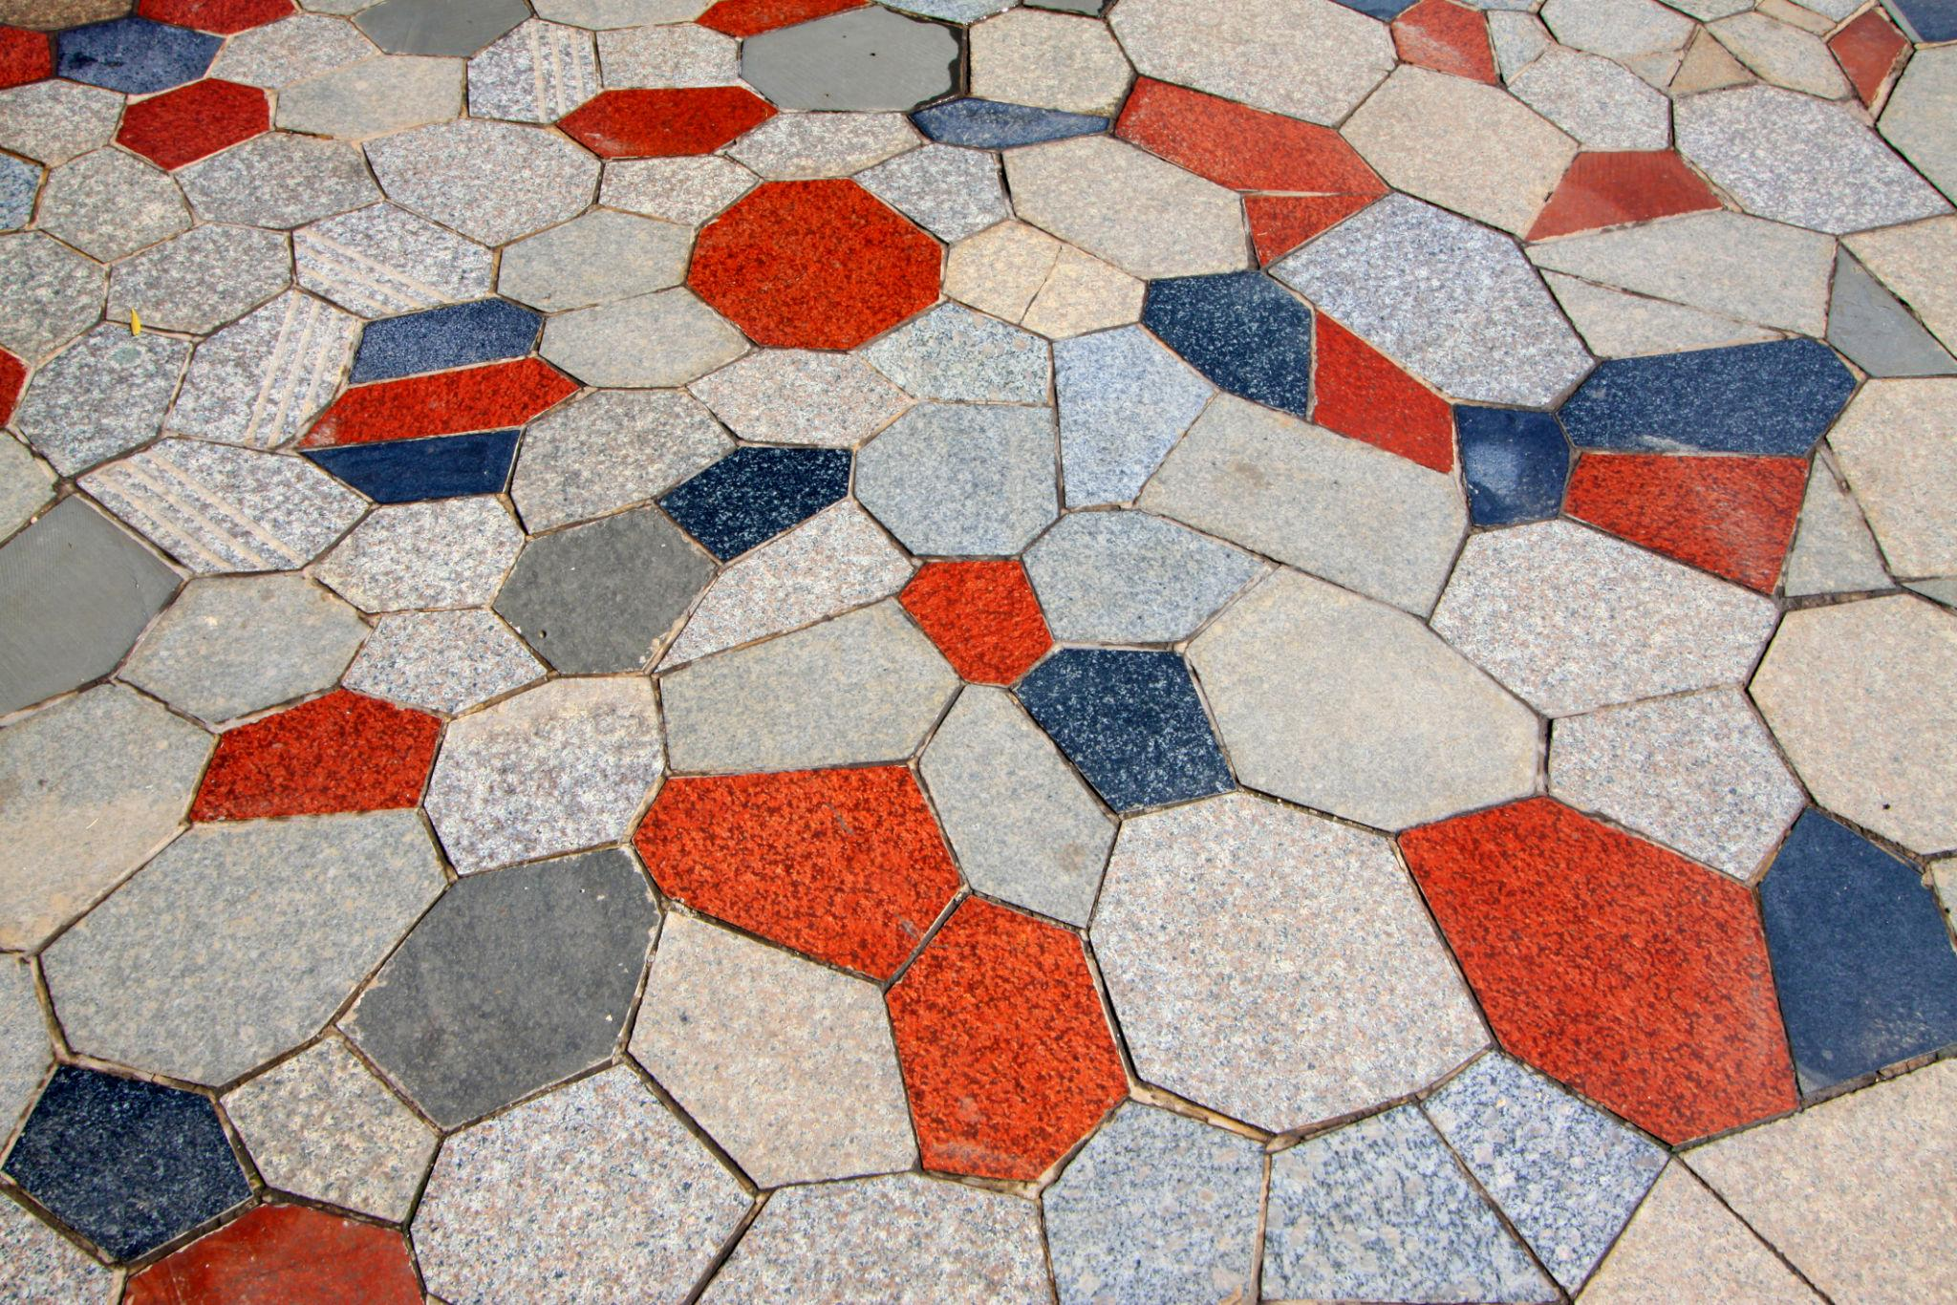

Key Points
# Source: AI Source: Provided by: [Data Path: Persons Table -> ID Column: 1, Name_En Column: Motasem Essam] -> From: [ChatGPT] on [7/25/2026]
- An Irregular Tessellation covers a plane without gaps or overlaps.
- Its tiles are not restricted to one regular polygon.
- Tiles may be irregular polygons or different types of polygons.
- A uniform vertex configuration is not required.
- The angles around an interior vertex must total:
$$\boxed{{360}^{∘}}$$
- An irregular tessellation may be periodic or non-periodic.
- Irregular does not necessarily mean asymmetrical.

Conclusion
# Source: AI Source: Provided by: [Data Path: Persons Table -> ID Column: 1, Name_En Column: Motasem Essam] -> From: [ChatGPT] on [7/25/2026]
An Irregular Tessellation is a plane-covering arrangement in which the strict uniformity of regular and semi-regular tessellations is not required. It provides a broad class of tessellations that can use irregular polygons, multiple tile shapes, and non-uniform vertex arrangements while still satisfying the fundamental requirement of complete coverage without gaps or overlaps.

